Family Salt Dough Crown of Thorns
The salt dough crown of thorns is a great visual reminder to children of Christ's suffering. It also helps children if you explain that our sins bring discomfort to Jesus, but that we can comfort Jesus by our sacrifices and good works. Children enjoy making the crown as a family, everyone can participate and it encourages togetherness during the Lenten season.
With each sacrifice he makes, that child/adult pulls a toothpick out of the crown. The idea is to remove all the "thorns" from the crown by Good Friday. You can put in a few more toothpicks than you think are necessary, kids really make an effort to do nice things as they see the tangible impact on the crown. Removing the thorns help children to see how they can help Christ carry his cross and adults witness positive acts of kindness.
When all of your thorns are removed, decorate the crown for the Easter table. Paint it, hot glue flowers or jewels, glitter, stickers, pearls … whatever you choose as family. It is a nice reminder of what can be done out of love. Once the crown has been decorated, add a homemade Paschal candle or dyed eggs in the center and pray together as a family.
You will need:
4 cups flour
1 cup salt
Water
Toothpicks
Directions:
Mix flour and salt. Mix enough water to make a stiff clay. (A little warmth helps dissolve the salt.) Knead until smooth to remove any air bubbles. Roll three long ropes and loosely braid them. Form braid into a circle and stick toothpicks loosely throughout the entire crown (If they are embedded too deeply they cannot be pulled out intact.) Bake at 350° F for an hour or until it is dry and light brown.

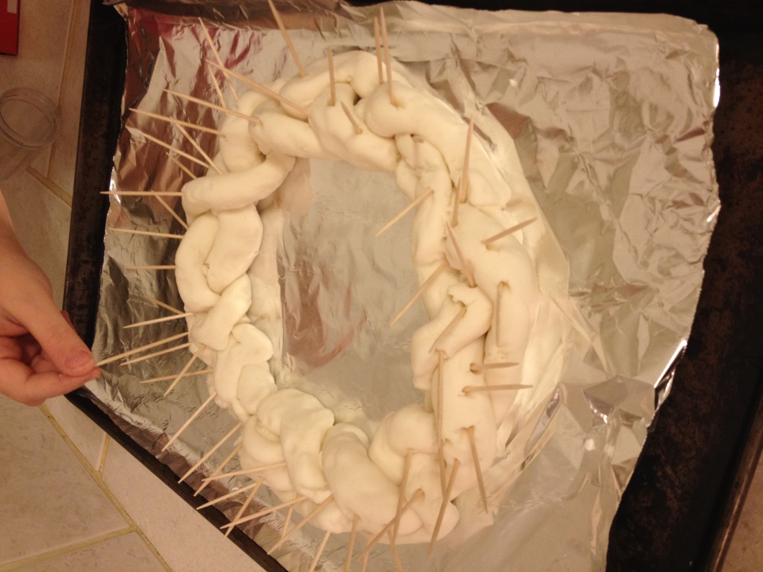
Personal Dough Crown of Thorns
The personal dough crown of thorns is the same concept and design as the salt dough crown but this is a smaller version made for a child’s bedroom or small area in the home. Great for older children away at college or for each child in the family to work on their own Lenten journey. In place of flour and salt, use a one large jar of Play-Doh, you can be very creative and make easy braids or custom designs. Remove the thorns with each act of kindness by Good Friday and decorate for Easter. A smaller homemade Paschal Candle or dyed egg can be placed in the center.
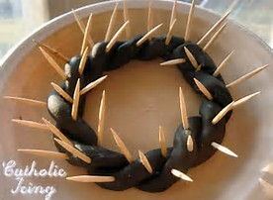Photo Credit: Catholic Icing

